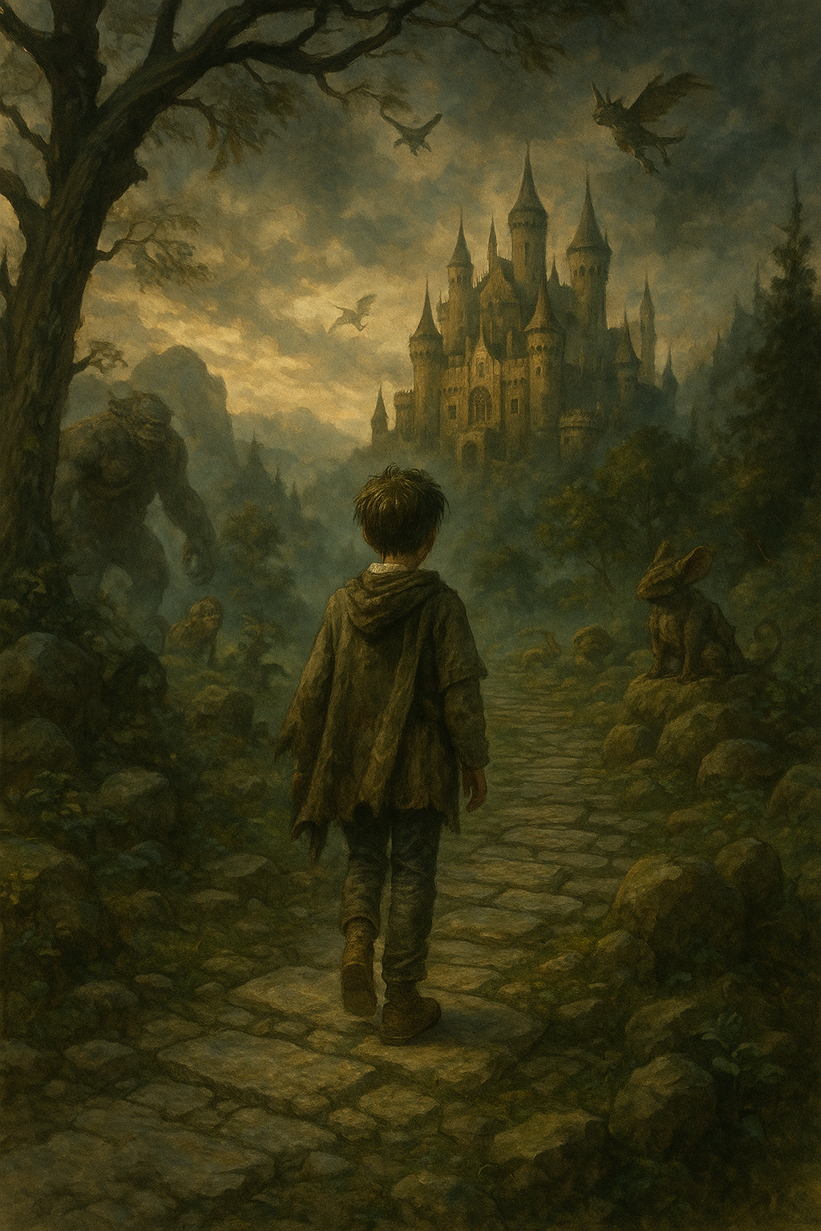Story 1

from pathlib import Path

# Define the full story text based on the outlined plot

story_text = """

Title: The Realm of Echoes

By: Allen Rehkemper & AI

Elias was thirteen the night the world stopped making sense. He had returned from school to find the house hollow. No note. No explanation. Just silence, louder than anything he’d ever heard. His parents were gone.

He waited. Days turned to weeks. Teachers stopped calling. Neighbors stopped asking. He scavenged what food he could, wore the same clothes for days, and kept a candle lit by the window every night. Just in case.

Then came the flickers.

At first, shadows that danced just outside his vision. Then whispers—words that didn’t belong in this world. A glimmering figure appeared behind the condensation on the bathroom mirror, calling his name in a voice like wind chimes. “Elias…”

He thought he was losing his mind. But the more he saw them, the more they became real. One evening, as he wandered through the woods behind his neighborhood, the air shimmered like heat off asphalt, and a creature stepped through.

It looked like a fusion of owl and cat—wise, regal, absurd.

“I am Corwin,” it said, blinking mismatched eyes. “You are needed.”

“I think you’re in the wrong universe,” Elias said, stepping back.

“You’ve been seen, child. You’re the Warden of Realms.”

He laughed. “I’m just a kid whose parents left him.”

But that night, in dreams or waking (he wasn’t sure), the world split. A rift tore the sky open, and Elias stepped through into a land where the grass whispered secrets and the stars moved like fireflies.

The Realm of Echoes.

It was beautiful—unreal in every way. Trees that breathed. Rivers that sang. Creatures that bowed when Elias passed. They called him “High One,” and when he asked why, they told him of a prophecy: A boy with sorrow in his bones would heal the realm from the Dark Mist.

Corwin guided him. He met allies—a girl with hair like fire who could summon storms, a talking stone that rolled beside him cracking riddles, and a phoenix that refused to burn.

He faced trials. Solved puzzles that tested his heart, not just his mind. Faced creatures corrupted by the Mist—twisted versions of joy, hollow-eyed and desperate.

Then came the cave.

The mirrors.

Each one showed a version of Elias: happy, angry, broken, cruel. And behind one—his parents. Smiling. Reaching.

“Are you real?” he whispered.

They didn’t answer.

At the cave’s end stood the Echo King. Tall. Familiar.

It was Elias.

But older, crueler. A version of him that had given up.

“You created me,” the Echo King said. “You needed me.”

“No,” Elias said. “I needed truth.”

They fought—not with fists, but with memories. Laughter. Tears. Screams into empty houses.

Elias won.

The realm crowned him. The sky lit with auroras. Creatures danced.

He was home.

But the realm began to fade. Corwin wept. “This place… it was never meant to stay. You built it to survive.”

Elias clutched the crown. “Then let it go.”

He woke in a hospital bed.

White walls. Fluorescent lights.

The social worker beside him looked exhausted. “You’re back,” she whispered.

No parents.

No magic.

But someone had stayed.

Elias cried—and this time, it wasn’t to escape.

It was to begin.

---

Sometimes, the worlds we create are the bridges back to ourselves.

"""

# Save to .txt file

story_path = Path("/mnt/data/The_Realm_of_Echoes.txt")

story_path.write_text(story_text.strip())

story_path

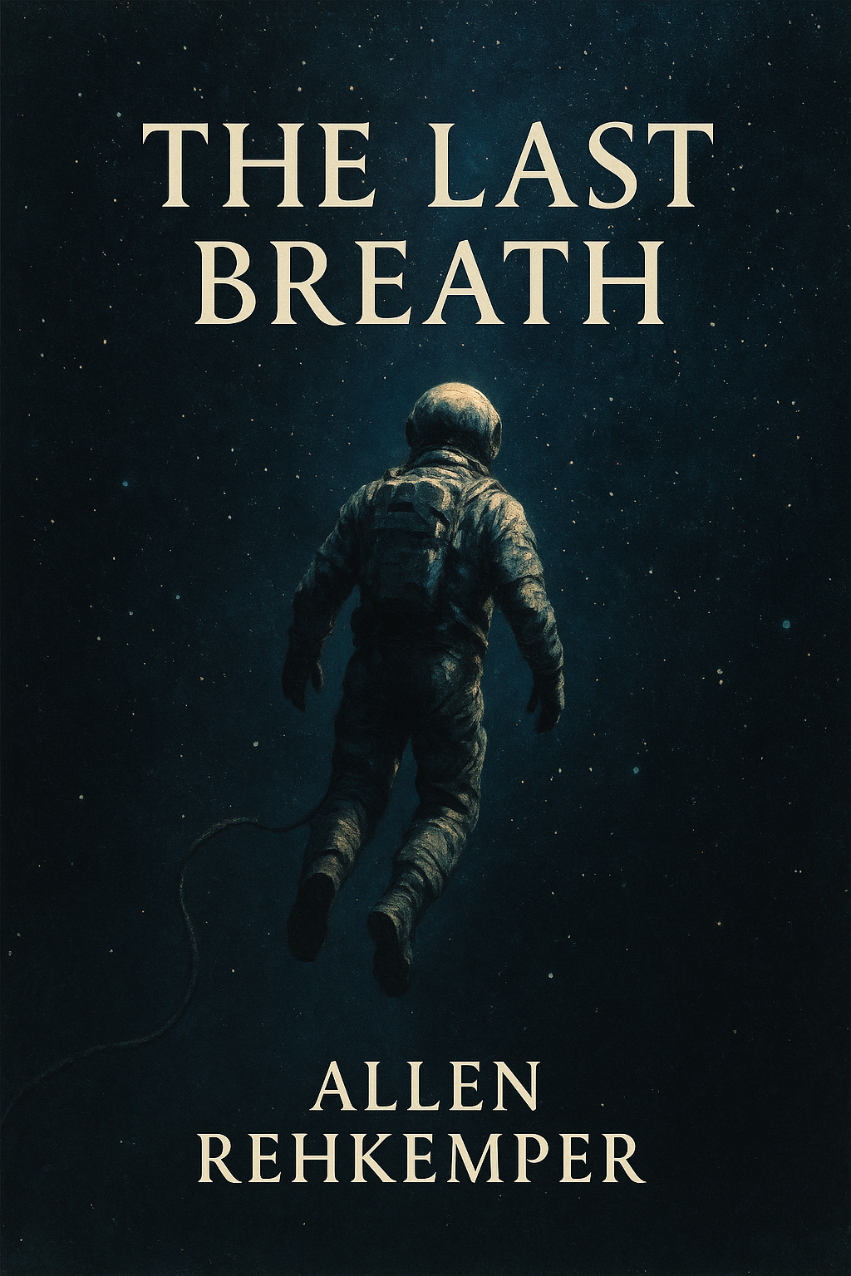

**Story 2**

from pathlib import Path

# Define the second story text again after code state reset

story_text_2 = """

Title: The Last Breath

By: Allen Rehkemper & AI

They say death is cold, but space is colder.

Commander Rhys Lorne floated quietly in the emergency pod, severed from the main shuttle. A steady hiss echoed behind his breath—oxygen venting slowly through the filtration system. There was enough for him, and only him. And that was the point.

"Manual detachment confirmed," the onboard AI had reported thirty-seven minutes ago. He had heard the muffled cries through the comms before he disabled them. Better for the crew to focus on surviving. Better for him not to hear them scream his name.

He was alone now.

At first, anger. Why had the systems failed? Why had he been the one to decide? He slammed a fist against the wall, and the pod creaked in reply. Fury was fire in his chest, but it burned out quickly in the vacuum of inevitability.

Then came bargaining. He played with fantasy: maybe the station would dispatch a rescue drone. Maybe the shuttle had one more burst of fuel. Maybe.

But reality was quieter than hope. And so, Rhys drifted.

Denial whispered next. He rechecked the gauge. Ninety minutes. Maybe if he powered down the heaters, conserved breath. But the math didn't lie. There were no more calculations to run. He was the variable that had to be removed.

As he drifted further, the stars sharpened into clarity. The galaxy sprawled before him, endless and magnificent. Nebulas shimmered like oil on water. A dying red giant blinked slowly in the distance, pulsing like a tired heart.

He closed his eyes.

And memory came.

Running barefoot through rain on Terra-7. His sister’s laughter. The way sunlight caught his mother’s hair. The first day he wore the uniform. The night he met Oren—his first love, the way his voice would tremble when he read poetry aloud. Faces swam through time. Friends. Lovers. A teacher who believed in him when no one else did. The crew—so young, full of questions.

He could have been bitter. But instead, he smiled.

Because they would live.

Ensign Talbot would finally return to Earth and see her newborn son. Jin would finish that novel. Dr. Kova would finish her research that might cure dozens of rare diseases.

Rhys had given them time.

A minute passed.

Then another.

Grief settled in like mist—quiet and steady. He let it move through him. He cried, and the tears floated. One drop drifted up, dancing between him and the stars.

He whispered, "It was worth it."

Acceptance was not a flag to wave. It was the exhale after the storm. The silence that follows a final note in a beautiful song.

He turned the pod’s lights off.

The stars filled every inch of his view. Light and darkness, infinite.

His heartbeat slowed.

"Goodbye," he whispered—not to space, but to life.

He closed his eyes.

And drifted, forever watching the stars.

---

Sometimes, the greatest act of love is letting others go on without you.

"""

# Save to .txt file

story_path_2 = Path("/mnt/data/The_Last_Breath.txt")

story_path_2.write_text(story_text_2.strip())

story_path_2

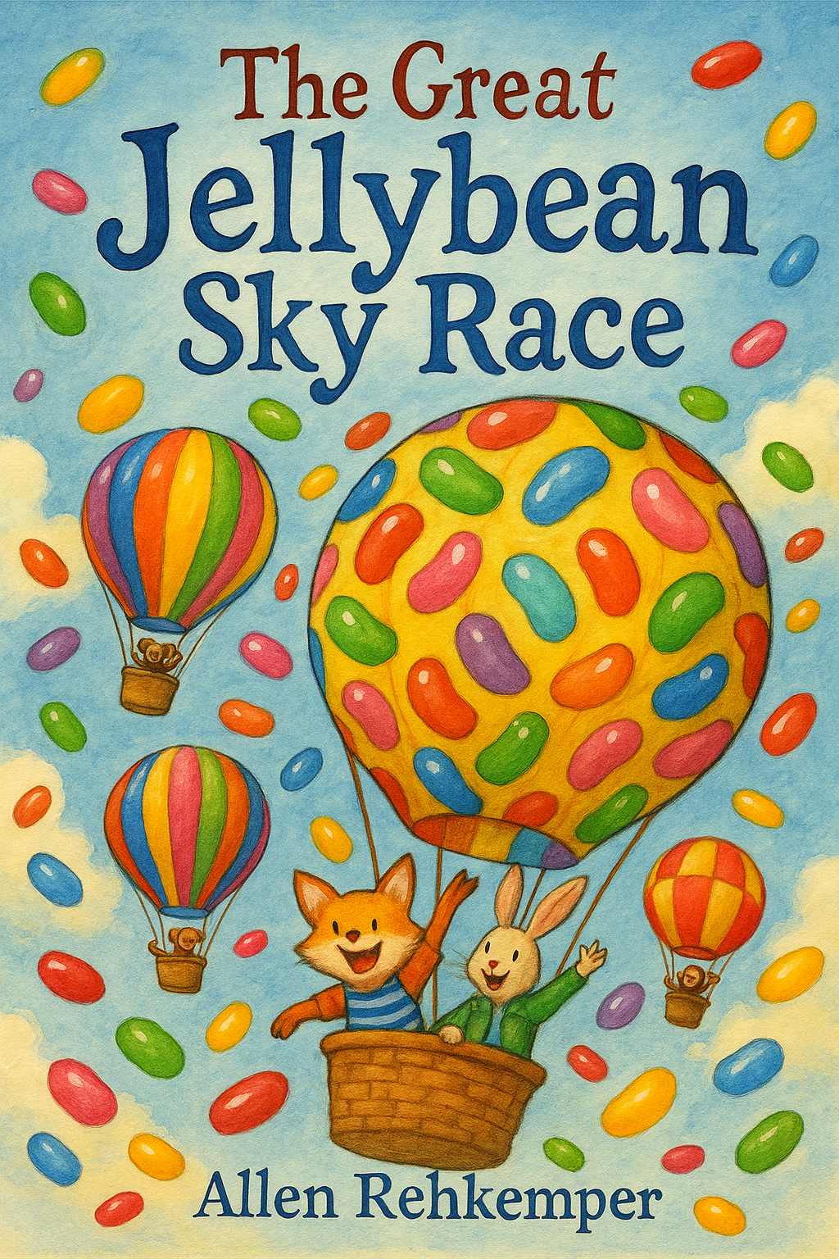

**Story 3**

from pathlib import Path

# Define a whimsical, colorful, imaginative story with quirky characters

story_text_3 = """

Title: The Great Jellybean Sky Race

By: Allen Rehkemper & AI

In the land of Blippity-Bloop, where the clouds tasted like whipped cream and the rivers giggled when you stepped in them, something extraordinary was about to happen.

Every year, the kingdom hosted the most anticipated event in all the magical realms: The Great Jellybean Sky Race.

This wasn't your average sky race, mind you. Oh no. Competitors zipped through rainbow vortexes on flying contraptions made of marshmallows, banana peels, or sometimes just stubborn geese who had nowhere better to be.

Our unlikely hero? A slightly lopsided, extremely enthusiastic turtle named Bobo.

Bobo had never flown anything in his life, unless you count that one time he tripped on a trampoline and launched into a cake.

This year, however, Bobo was determined.

He built his flying machine—affectionately named “The Soggy Pickle”—from a unicycle, three balloons, a teapot, and something that may or may not have been part of an old blender.

“Are you sure this is... airworthy?” asked his best friend, Princess Parsnip, who was wearing a hat made entirely of singing spoons.

“Pars, when have I *ever* let a lack of logic stop me?” Bobo grinned, one eye slightly more excited than the other.

At the starting line, chaos buzzed.

The reigning champion, Sir Fluffington the Third (a hamster with a monocle and a caffeine problem), revved up his jellybean-powered rocket-scooter.

Next to him, a pair of synchronized otters stretched dramatically while their coach—a talking cucumber named Kevin—gave them pep talks through a megaphone made of licorice.

The trumpet blared (it sneezed jelly every time), and the racers were off!

Bobo soared… sideways.

“The Soggy Pickle wasn’t built for speed,” he admitted mid-air, “but it *was* built for snacks!” He pulled out a baguette propeller and flung it into the wind. The machine hiccupped, spun like a confused flamingo, and suddenly zoomed forward with a squeal of delight.

They soared through cotton candy clouds, dodged grumpy rainbows, and waved at a choir of flying ducks who were singing ABBA.

Halfway through, Sir Fluffington got stuck in a gooey caramel swirl and had to be rescued by a team of airborne walruses.

One of the otters fell asleep mid-barrel roll. Kevin screamed.

And Bobo? Bobo just laughed. “This is better than sky yoga!”

He somersaulted The Soggy Pickle through a triple loop-de-loop and landed on the finish line upside down… first.

The crowd exploded in cheers and jellybeans.

Bobo blinked. “Did I win? Or did I hallucinate from all the helium?”

Princess Parsnip ran up with a trophy shaped like a waffle. “You did it, Bobo! You’re the new Sky Champion!”

Bobo lifted the trophy triumphantly. “To all the underdogs, over-snackers, and dreamers with duct tape—this one’s for you!”

And from that day on, in Blippity-Bloop, it was said that anything was possible—as long as you had imagination, courage, and a mildly functional teapot.

---

Moral of the story: Sometimes, flying sideways is still flying.

"""

# Save to .txt file

story_path_3 = Path("/mnt/data/The_Great_Jellybean_Sky_Race.txt")

story_path_3.write_text(story_text_3.strip())

story_path_3

**Story 4**

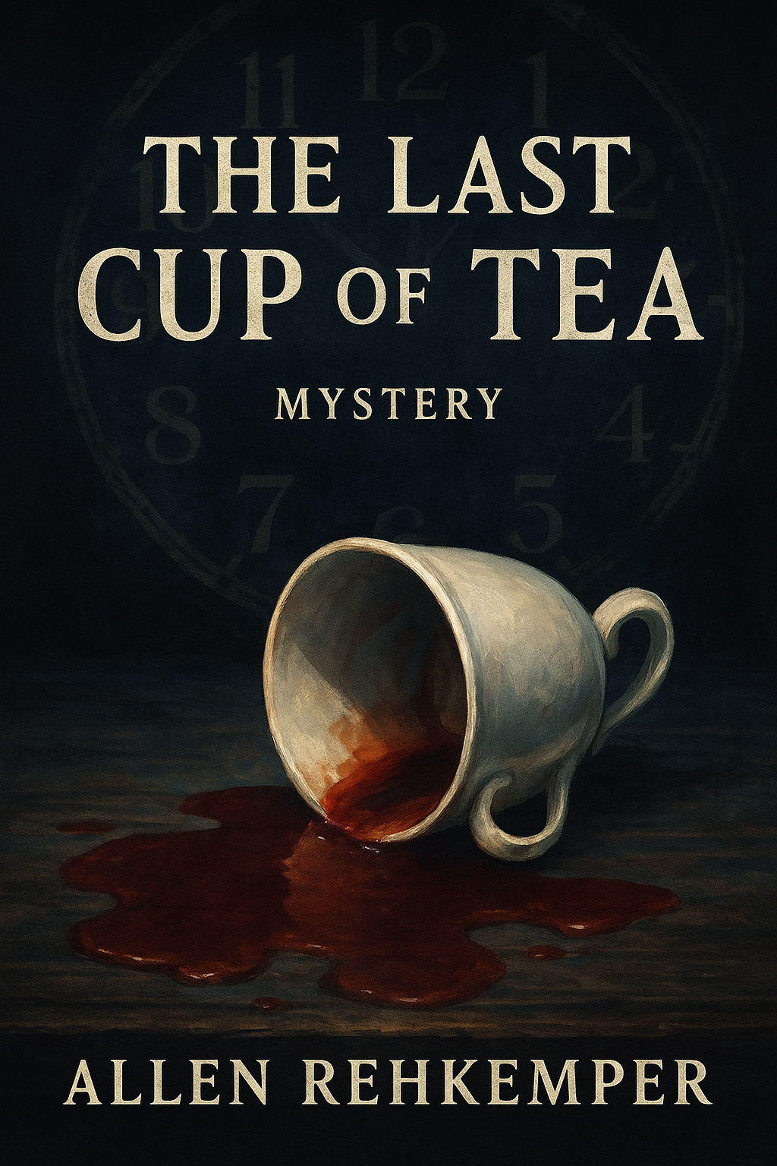from pathlib import Path

# Define the short mystery story

story_text_4 = """

Title: The Last Cup of Tea

By: Allen Rehkemper & AI

The storm rolled in just after sunset, cloaking the small English manor in shadows and thunder. Five guests had arrived for dinner at Windmere House, each of them invited by a mysterious letter signed only, “A Friend.”

By 8:00 p.m., the lights flickered. At 8:15, they found the host—Professor Albert Hensley—dead in the parlor, slumped in his armchair, a half-finished cup of tea on the table beside him.

The doors were locked. The phone line was dead. And the killer, as everyone realized, was still in the house.

Inspector Marian Griggs, who had also received an invitation and coincidentally retired just last week, took charge. “No one leaves until we figure this out,” she said, straightening her scarf.

The guests:

- **Mrs. Lavinia Blackwood**, a novelist with ink-stained fingers and a habit of watching people just a little too closely.

- **Dr. Remy Glade**, a chemist with shaky hands and a sharp tongue.

- **Mr. Felix North**, a charming gambler who never seemed quite broke.

- **Miss Clara Finch**, a shy schoolteacher with a secret.

- **Chef Benoît**, a French culinary expert who claimed to have met the professor in Paris.

They all denied knowing Hensley well. But someone had brewed that tea. Someone had poisoned it.

Griggs asked questions, observed movements, and noted details.

Mrs. Blackwood spoke of inspiration and character motives, but stumbled when asked if she’d visited the house before.

Dr. Glade fumbled when asked to identify the tea blend. “Something herbal?” he guessed. But Griggs noticed the distinct scent of **oleander**, a poison he would surely recognize.

Mr. North flirted with Clara, deflecting suspicion, but a loose page in his coat pocket held **a betting slip** signed by Hensley. A debt?

Chef Benoît was missing at the time the tea was poured. “I was in the cellar,” he said. “Looking for...wine.”

Griggs paced the drawing room. Then she spotted it: a set of six cups on the sideboard. One was missing. The cup on the table wasn’t part of the set—it was a plain white mug.

Clara gasped. “That’s my mug! I brought it with me from the kitchen—it’s how I keep my anxiety tea separate!”

Griggs snapped her fingers.

Only Clara had a reason to use a different cup. But that cup—the one meant for her—was the poisoned one. Which meant...

She wasn’t the killer.

“She was the target,” Griggs said. “Someone swapped the cups.”

They all turned to **Dr. Glade**, who had insisted on “helping” with the tea.

“You owed her father a great deal, didn’t you?” Griggs said. “A ruined career... and Clara was about to reveal the truth. So you meant to silence her.”

Dr. Glade’s face went pale. “I... I made a mistake.”

“Yes,” Griggs replied. “A deadly one.”

The storm continued to rage, but the mystery had passed.

---

Sometimes, the cup you choose reveals more than just your taste.

"""

# Save to .txt file

story_path_4 = Path("/mnt/data/The_Last_Cup_of_Tea.txt")

story_path_4.write_text(story_text_4.strip())

story_path_4

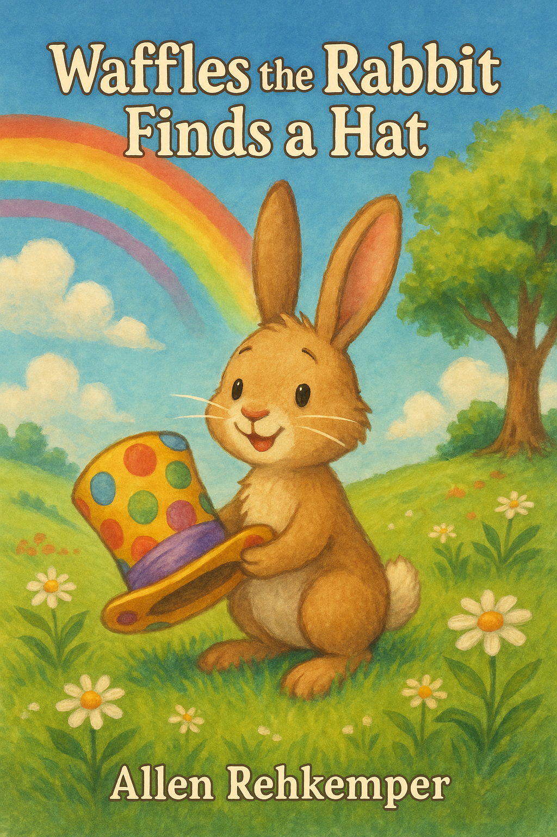

**Story 5**

**from pathlib import Path**

**# Define the children's short story**

**story_text_5 = """**

**Title: Waffles the Rabbit Finds a Hat**

**By: Allen Rehkemper & AI**

**Waffles was not your ordinary Rabbit.**

**He didn’t care for naps or digging up Carrots. No, Waffles loved one thing more than anything else in the whole wide world… **hats**.**

**Big hats, tiny hats, shiny hats, and hats shaped like bananas—Waffles loved them all.**

**He lived with Grandma Nelly in a cozy blue house with a red door and a garden that smelled like jellybeans. Every morning, Grandma Nelly would say, “No more hats, Waffles. You have seventy-two already!”**

**But Waffles would smile (as only a rabbit can) and sneak out on a new hat-finding adventure.**

**One sunny Tuesday, Waffles put on his polka-dot detective cap and declared, “Today, I will find the most *wonderful* hat in the world!”**

**He trotted down Jellybean Lane, past the giggling tulips and the mailbox that liked to hum.**

**First stop: Mr. Toadsworth’s Bakery.**

**“Any new hats?” Waffles asked, sniffing the air.**

**“Only bread,” said Mr. Toadsworth. “But you’re welcome to this baguette shaped like a helmet.”**

**Waffles balanced the baguette on his head. “Too crusty,” he said, and wobbled on.**

**Next stop: The library, where Mrs. Snuggleboots the Owl wore glasses and knew everything.**

**“I need a hat that makes people giggle and say ‘Wow!’” Waffles told her.**

**Mrs. Snuggleboots blinked. “Try the old oak tree. Strange things grow there.”**

**So Waffles did.**

**At the old oak tree, he found it: a hat made of rainbow feathers, glittering buttons, a spinning top, and a small music box that played circus tunes.**

**It was perfect.**

**He ran all the way home.**

**Grandma Nelly gasped. “Waffles! That’s the silliest, happiest hat I’ve ever seen!”**

**And Waffles said proudly. “Hat number seventy-three.”**

**From that day on, Waffles became *The Rabbit With the Hat That Made People Laugh*.**

**He didn’t need riches or fish or fame.**

**Just a really good hat.**

**---**

**Sometimes, a great hat is all it takes to make the world a little brighter.**

**"""**

**# Save to .txt file**

**story_path_5 = Path("/mnt/data/Waffles_the_Cat_Finds_a_Hat.txt")**

**story_path_5.write_text(story_text_5.strip())**

**story_path_5**